Reading and Writing for Pleasure: Exploring systems and synergies that make a difference

The OU is research partner for the Mercers’ Company Special Initiative (2020-2023), funding six London-based programmes to develop reading and/or writing for pleasure with children and young people. Over the past eighteen months we’ve been talking, listening, reading and documenting, seeking to understand the key practices that make a difference. Literature reviews surrounding the research evidence behind RfP and WfP separately are being produced, whilst we are also using activity theory to explore synergies across the aims and approaches of the six programmes. Building on the focus and updates reported in the previous two project blogs (firstly introducing the project, and secondly highlighting the brilliant work of the programmes in pivoting since the pandemic), here we offer updates to interested colleagues about the broader backgrounds, aims and approaches of the six programmes within this special initiative.

Doorstep Library (DSL)
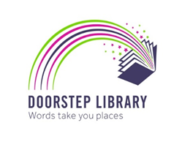
Doorstep Library is an unusual literacy charity that makes home visits to children aged 0-11, encouraging both children and wider family members to share, read together and borrow from a range of books brought into their homes by reading volunteers. As volunteers get to know children and families, book selections are tailored to their interests. This relationship-building is a critical element of the Doorstep Library offer, as regular volunteers become familiar and trusted visitors who can offer support in broader terms.
Innovating throughout different forms of COVID restrictions, volunteers still visited where it was possible – remaining literally on the doorsteps of homes – and the charity developed an online model for those they could not visit in person. Sustaining visits of familiar faces and regular spaces for enjoying and choosing reading, with no strings attached or tests of ability, were arguably significant in such uncertain and isolating times.
Founded officially in 2010, whilst Doorstep Library do receive referrals from schools, they are very focused on home-based reading and encouraging reading as a shared and enjoyable activity. Between 2020 and 2023 Doorstep Library aim to set up five projects in Camden, working within some of the 15% most deprived areas in England. Their volunteers work with any family in an identified area who wish to be involved, whilst being aware that some families may have greater need than others and scheduling resourcing accordingly. One of these five projects is established, with a second currently being established. The intention is to have ten volunteers in each area making weekly visits to 25 families, enabling the charity to reach more children who need support.

Get Islington Reading (GIR)
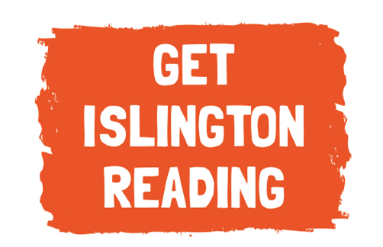
The National Literacy Trust (NLT) and the Reading Agency (RA) are working with schools and libraries in Islington to involve children aged 9-14 in reading for pleasure. Their work is targeted at pupils in transition from primary to secondary school. Now in the second year of this exciting project, GIR has reached 16 schools, linked with 3 local libraries.
GIR supports schools to audit their provision and plan to target areas for improvement related to a specific aspect of their school reading strategy. Each school is allocated a budget to support author visits, improve and diversify their library collection or provide additional copies of Islington Library Service’s Reading Road Map. Teachers have a further budget for activities and are supported to put together a reading for pleasure package that will work in their setting. These are based on interests of their young people and target age groups to engage them and their families in reading. In 2020-21, teacher twilights were offered online to support the project during lockdown. These proved particularly useful and are being further developed for the 2021-2022 group.
The library aspect of the programme is focused on developing an online reading game that links school and community activity. The Reading Agency has worked with Islington Public Library Service, children and teachers to help develop and plan ‘The Reading Adventure’, an online tool to support reading for pleasure for transition pupils. The game has six themes: cookery, art, science and technology, music, sport and nature. The Reading Adventure was launched for primary children in November 2021 and will be targeted at secondary children in 2022. It encourages children to sign up, select a theme and complete reading challenges based on their interests. Children can earn points by completing reading challenges in the game to personalise their own online reading room. The work is supported by partners: Arsenal in the Community, All Change Arts, Key Changes, Islington Youth Council and Islington Local Authority. GIR also signposts and promotes other initiatives and resources for teachers, children and families to encourage RfP, such as the Reading Agency’s Summer Reading Challenge and the RA and OU’s Teachers’ Reading Challenge. An exciting programme of events is planned for Children’s Mental Health Week, World Book Day and British Science week to connect the GIR community around reading.

Literacy Pirates
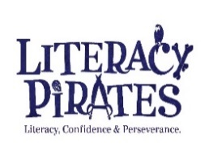
Literacy Pirates provides an after-school, year-long programme to improve the reading, writing and confidence of children who are falling behind at school and have fewer opportunities in their personal circumstances. The exciting learning programme is devised and led by teachers with input from 125 participating children (aged 9-12), called Young Pirates, and involves them visiting a physical pirate ship each week to receive extra help, one-to-one or in small groups, from an adult volunteer or ‘crew mate’ from the local community.
Each term the children work on creative projects such as: to write their own book, film script or website app which is then published and celebrated by the entire crew of shipmates. The ship has its own library of books for the children to choose from which they are encouraged to take home. Throughout the session, the Young Pirates read with their crew mates, take part in structured activities, and have the chance to meet other Young Pirates during the breaks.
When children were unable to attend in person, Literacy Pirates inventively built a virtual ship: a digital offer enabling children to still take part and to read with their volunteers in the online breakout rooms. The academic year started with children visiting the original Haringey pirate ship to enjoy their reading time, but since Christmas, children have temporarily returned to the virtual ship.

Ministry of Stories (MoS)
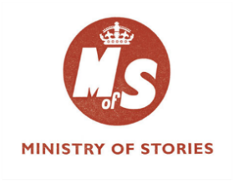
Ministry of Stories is a charity focused on leveraging the power of writing to transform children’s confidence, imagination and potential. MoS provides a range of after-school and in-school writing programmes for young people (5-18) who might not otherwise have access to similar opportunities. They have a writing centre in Hoxton Street (hidden behind their own fantastical shop, Hoxton Street Monster Supplies!). In the Mercers’ Company funded project ‘Writing Brighter Futures’, the team are working with a consortium of 10 primary schools in Tower Hamlets to motivate and support students to write for pleasure.
In the early stages, MoS created the consortium, explored how they could support schools through their creative writing work and ran workshops enabling school staff to build relationships with the team. These also offered a valuable space for teachers to reflect on their students’ particular requirements in the wake of Covid-19. In response to the schools’ needs, interests and desire to target the work at particular year groups, the MoS team co-planned and designed 10 bespoke projects for 2021-22. All schools were keen for this work to take place in person, so MoS have only recently begun delivery with pupils.
The programme, which spans three years, will variously involve professional writers, poets, storytellers and puppeteers as well as volunteer writing mentors who will deliver tailored opportunities closely aligned to existing curriculum topics. The MoS team seek to give children space to explore these topics from different angles and to take ownership of their own writing, finding pleasure in the process. The range of unique projects is diverse. Each lead to the production of different forms of writing and publications including, in 2022: tribal tales, mythologies, non-fiction, anthologies, newspapers (e.g. inspired by superheroes and Greek Mythology) and a ‘recipe of me’ (linked to identity, uniqueness and the school’s PSHE framework). In addition, a residential project has been developed which involves immersive story-making and writing at Goresfield Rural Studies Centre, in Essex. This is planned as a research and development initiative with a view to MoS creating an ongoing residential offer for other schools. As this exciting programme develops, the Ministry plan to showcase the schools’ journeys to build a broader awareness of their work across the borough.

Primary Shakespeare Company (PSC)
The Primary Shakespeare Company (PSC) started as a collaborative project between the National Theatre’s education department and Holy Trinity and St Silas CE School. The school had been running an annual Shakespeare project for several years involving all the pupils from Reception through to Year 6 working on a single Shakespeare play. At the same time, the National Theatre was running an initiative, Primary Classics, which toured a Shakespeare play to schools and delivered workshops. Two teachers at the school were involved in both projects and felt that there was potential to bring them together to benefit other schools, and this led to the first Camden Primary Shakespeare Festival.
The PSC approach in the Special Initiative involves recruiting a cluster of schools in each borough and working with them over six months. Each school takes responsibility for creating a performance that tells the story of one act of the focus play for that year. To do this, they work with practitioners to devise and rehearse sections. At the same time, the PSC team support the class teachers, through ongoing training and online resources, to use the play to plan and deliver lessons across the curriculum with literacy as the focus. Towards the end of the six months, all schools in a borough come together for a day at a theatre venue to share their work in an energising Festival of performance.
PSC’s aim is to engender a joy in creation, in creative writing, and to make children aware of the range of creative professions that might be open to them. Their most recent creative endeavour is a project involving five schools with 210 children from across seven classes working together on the performance. In order to engage children in writing for enjoyment they will be devising and writing an opera based on a theme arising from a Shakespeare play. The whole curriculum is designed with the participating teachers who are encouraged to adopt a drama-centred attitude with the opera becoming the hook for all subject areas. In addition to participating in the opera, children are also encouraged to respond to the content and experience through writing activities, both at school and at home.

World Book Day (WBD)
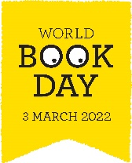
World Book Day is an internationally recognised annual event for over 20 years. As an organisation it has been working since 2019 to strengthen its aim to take the moment of celebration – the annual World Book Day – and to embed and add depth of meaning to this, through evidence-based engagement. To achieve this WBD have been collaborating with the OU, CLPE and NLT, and shaping a new approach and building educational resources to encourage schools, children and parents to read for pleasure. WBD is working to change the discourse around reading as a skill, focused on specific books, to reading as an opportunity, focused on behaviours.
The celebration is still there, as are the dressing up as characters and other fun activities, but WBD acknowledged that if teachers, schools, parents and children are coming away from the celebration without any behaviour change, then an opportunity has been missed to embed the enjoyment of reading more widely. WBD is also seeking to identify and target efforts where need is greater, focusing on areas of disadvantage, to reach children who aren’t otherwise reading due to having few books at home, perhaps being or being positioned as reluctant readers, or for other reasons find themselves in low literacy environments. This involves re-thinking how to celebrate RfP for all children– for those who love reading, those who find it easy but aren’t that bothered, and those who find reading difficult. Breaking this down requires making opportunity, time and space for children to choose to read, and to then be able to choose what and when to read in an environment that offers genuine and appealing choices.
Pilot resources to support such change are currently being developed through intensive collaboration with teachers and children at three London-based primary schools. Current work is also supporting parents with very young children to value reading as an enjoyable activity with their babies and toddlers, including producing videos of early years literature and prompts for reading together.

Next steps
Above we’ve outlined the focused work in which the six programmes are engaged. Next steps in the project from our point of view as Mercers’ research partner includes hearing perspectives from volunteers and teachers: finding out why they chose to be involved, and what they see as important for the young people who access these activities. With Covid restrictions showing signs of easing, we’re hopeful of being able to visit the six programmes in action too. This will be a wonderful way of seeing on the ground the guiding principles shared via various voices and documents over the past two years. No doubt we’ll see how the six programmes bring their work to life and support children and young people’s reading and writing for pleasure, in different ways and different contexts. This will enable us to continue to draw together the synergies and threads that are proving they make a difference.

Alison Twiner is Research Associate at The Open University, and Hughes Hall, University of Cambridge. Her research interests focus on supporting and exploring meaning making, via various tools and in various contexts. She is particularly interested in the use of talk, various technologies, as well as dance, in facilitating and resourcing meaning-making activity and as alternative ‘ways in’ to understanding.
Twitter: @alison_twiner
alison.twiner@open.ac.uk
Alison is a research team member of the Mercers’ Company Special Initiative on Reading and Writing for Pleasure, alongside Prof Teresa Cremin, Dr Liz Chamberlain and Dr Helen Hendry .

