Title
Name

- Create a SHORT interesting title for your work ( No colons please, they don’t suit the web space)
- Add your name (Remove the word title and name!)
- Add your Twitter handle and a visual if you wish.

Context
- Explain where you work, naming your school or ITE institution and the county it is in
- Include your school logo, here or above in the Title section
- You may wish to highlight an aspect of the school’s development plan if it connects to this RfP work

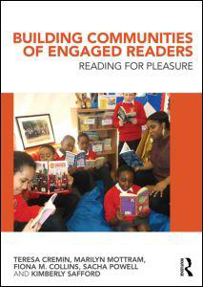
OU Research inspiration and rationale
Describe which one or more of the Open University’s Teachers as Readers (TaRs) findings (1-5) inspired you to develop RfP and why.
TaRs found that in order to foster RfP effectively, teachers need to develop:
1. Considerable knowledge of children’s literature and other texts
2. Knowledge of children’s reading practices
3. A reading for pleasure pedagogy which includes:
- Social reading environments
- Reading aloud
- Independent reading
- Informal book talk, inside-text talk and recommendations
4. As Reading Teachers: teachers who read and readers who teach
5. Reading communities that are reciprocal and interactive. (from Cremin et al., 2014, above)
The website document More Research Details which summarises the findings for each strand may be useful.
Feel free to connect to other research on reading too.

Aims
Outline the specific aims you focused on in your work based on the research (we recommend a small focus). Consider the children’s needs too: did you seek e.g. to respond to a lack of interest or low reading stamina, or something else?
Connect the aims clearly to one of the key TaRs research findings (Cremin et al., 2014).
Outline
- Briefly describe the work you undertook to achieve your aims.
- Use VISUALS to convey this work well, these are essential!
e.g. photos of the classroom, of displays, of relevant books, of children (check permissions), of events, of staff engaged in reading etc.
- Do embolden paragraph headers or key words to help the reader.
Impact
Detail the impact that your specific work had on a small group of children and their RfP, and/or on you as their teacher/other staff.
Note evidence e.g. through your observations of shifts in attitudes or behaviour, and quotes from children and/or staff. This might focus on particular children and include photos. The NLT diagram may help you consider elements to reflect and comment upon.
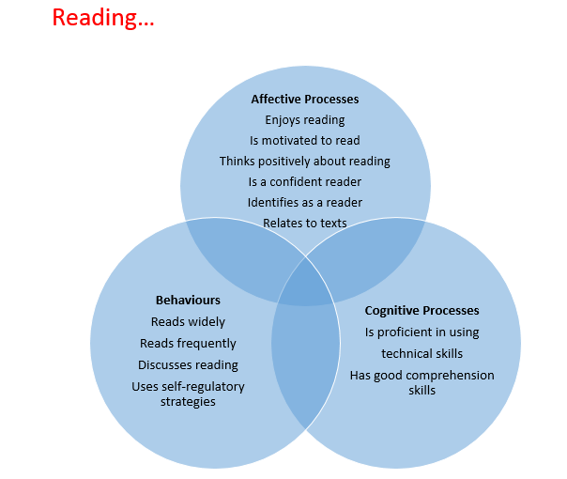
ROGO model evidence base National Literacy Trust 2017, page 2
Reflections on impact the TaRs research had on practice
Reflect on which specific aspects of the TaRs research influenced your practice and in what ways.
What are your plans and next steps to support children’s volitional engagement as readers? Might this be linked to another aspect of TaRs?
Do look back and check it is as visually engaging as possible!
We have found these are the most read/popular!

